**Build your model-driven app from scratch**

Model-driven app design is a component-focused approach to app development. In this topic, you simplify how to create a model-driven app by using one of the standard entities that's available in your Power Apps environment.

**Intro**

* Create new environment @PowerApps Admin centre using community subscription
* Create database in new environment for CDS
* Create entities, relationship, field, option set field
* Create UI components App, Site Map, Form, View
* Create app
* Publish app
* Run the App using Mobile app

**Create your model-driven app**

1. Sign into Power Apps
2. Select the environment you want or go to the Power Apps admin center to create a new one.
   1. Here for our lab section we need community environment to create multiple environment for this bootcamp
   2. Click <https://powerapps.microsoft.com/en-us/communityplan/> and login with the same credentials, then it will allow you to create multiple environments.
3. On the Home page, select Model-driven app from blank.
4. On the Create a New App page, enter the following details, and then select Done:
   1. **Name**: Enter a name for the app, such as My first app.
   2. **Unique Name**: By default, the unique name uses the name you specify in the Name box without spaces and preceded by the publisher prefix and an underscore (_). For example, crecf_Myfirstapp.
   3. **Description**: Type a short description of what the app is or does.

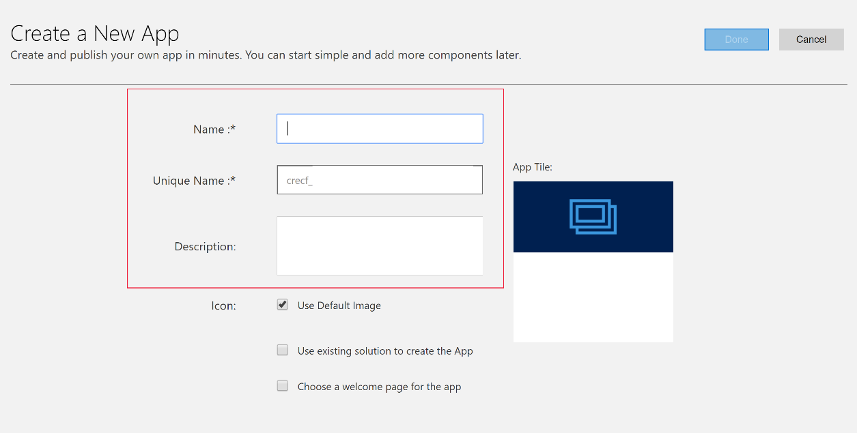

## Add components to your app

From the app designer you add components to your app.

1. Select the **Open the Site Map Designer** arrow to open the sitemap designer.

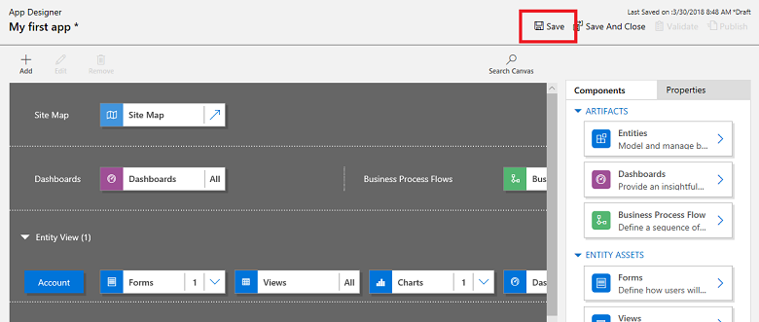

1. On the sitemap designer select **New Subarea**, in the right pane select the **Properties** tab, and then select the following properties.

* **Type**: Entity
* **Entity**: Account

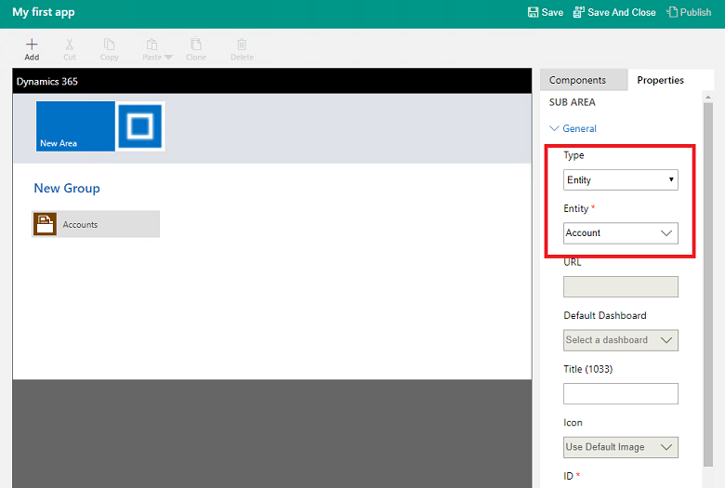

1. Select **Save And Close**.
2. On the app designer canvas select **Forms**, and then on the right pane under the **Main Forms** group select the **Account** form.

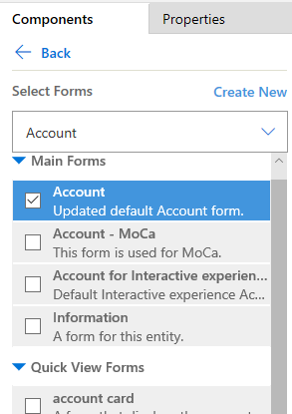

1. On the app designer canvas select **Views**, and then select the **Active Accounts**, **All Accounts**, and **My Active Accounts** views.

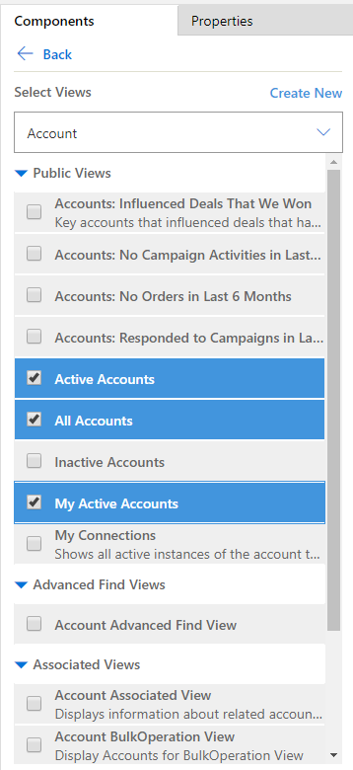

1. On the app designer canvas select **Charts**, and then select the **Accounts by Industry** chart.
2. On the app designer toolbar, select **Save**.



## Publish your app

On the app designer toolbar, select **Publish**.

After publishing the app it's ready for you to run or share with others.

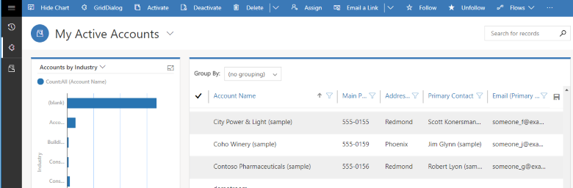

**Run a model-driven app on a mobile device**

After the app is created and then shared with you, you can run that app on the Dynamics 365 mobile app or in a web browser on tablet. In this section, you'll learn how to run a model-driven app on a mobile device.

## Run the model-driven app

Model-driven apps don't run in the Power Apps mobile app. Instead, you run a model-driven app on a mobile device using the Dynamics 365 mobile app. If you don't have the Dynamics 365 for phones and tablets app installed, you can still use the web browser on your tablet, as long as your device has sufficiently high screen resolution. However, for full functionality and optimized experience, we strongly recommend that you use the Dynamics 365 for phones and tablets mobile app.

**Note** : Using the web browser on your phone to run your model-driven apps isn't supported; you must use the Dynamics 365 for phones app.

### **Use the mobile app**

Install the Dynamics 365 for phones or Dynamics 365 for tablets app from your device’s app store.

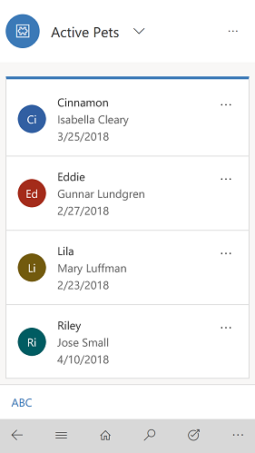

### **Run in your tablet's browser**

Go to the dynamics 365 or enter the app URL directly into your tablet's web browser and follow the directions on your screen to load the app.